Adding the Local Users and Groups Snap-in
1. In the Search box, type MMC and press Enter.
2. If a warning box appears, click Yes.
3. Select File ➢ Add/Remove Snap-in.
4. Scroll down the list and highlight Local Users And Groups, and then click the Add
button (shown in Figure 8.3).
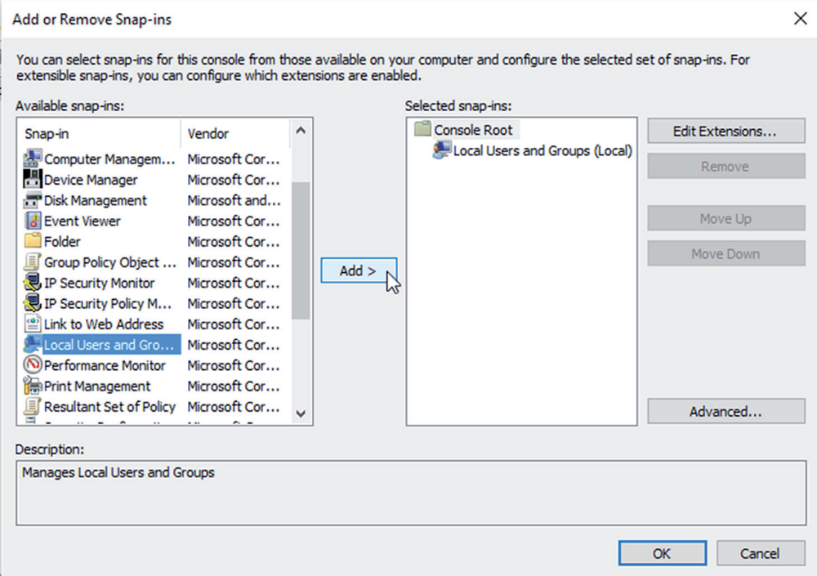
5. In the Choose Target Machine dialog box, click the Finish button to accept the default
selection of Local Computer.
6. Click OK in the Add Or Remove Snap-ins dialog box.
7. In the MMC window, right-click the Local Users And Groups folder and choose
New Window From Here. You will see that Local Users and Groups is now the main
window.
8. Click File ➢ Save As. Name the console Local Users and Groups and choose Desktop
under the Save In pull-down box. Click the Save button. This is creating the shortcut
shown in Figure 8.4 for you to use in exercises throughout this chapter.
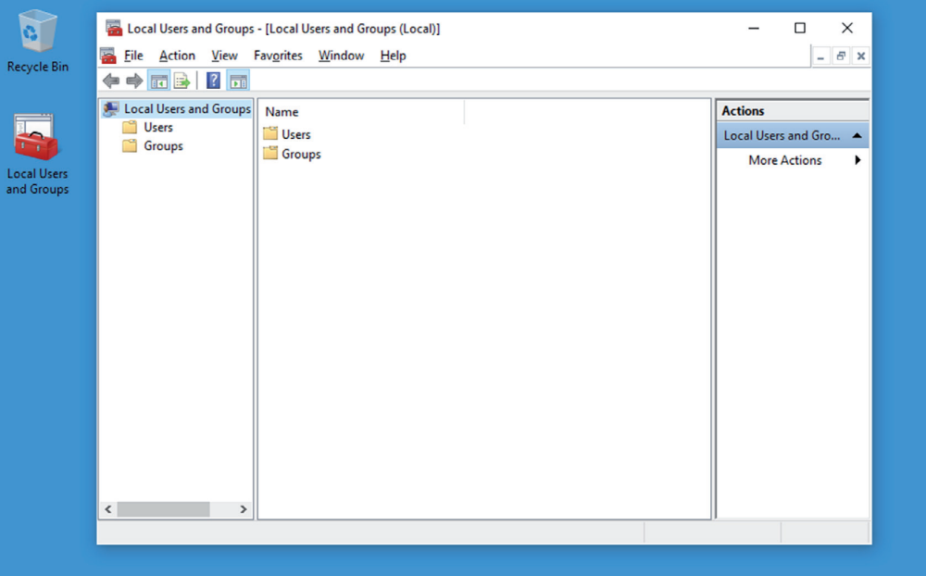
9. Close the MMC snap-in. You should now see the Local Users and Groups snap-in on
the Desktop. You can also open the Local Users and Groups MMC from the Computer
Management utility, which you’ll do in Exercise 8.2. Complete the following exercise
for opening the Local Users and Groups utility from the Computer Management utility.

Accessing Local Users and Groups via the Computer Management Utility
1. Right-click the Start button and then choose Computer Management.
2. In the Computer Management window, expand the System Tools folder and then the
Local Users and Groups folder.

